1. Single Catch

Program :

#include<iostream>

#include<string>

using namespace std;

int main()

{

int age;

string name;

try

{

cout << "Enter Name : ";

cin >> name;

cout << "Enter Age : ";

cin >> age;

if (age<18)

{

throw "Age is lesser than 18";

}

else

{

cout << "You are elgible to vote.";

}

}

catch (const char \*e)

{

cout << "You are not eligible to vote.";

}

return 0;

}

Output :

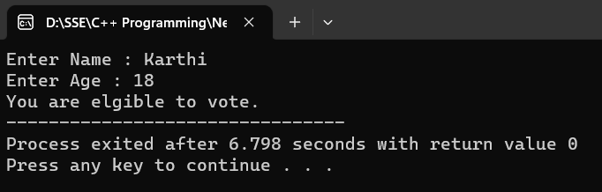

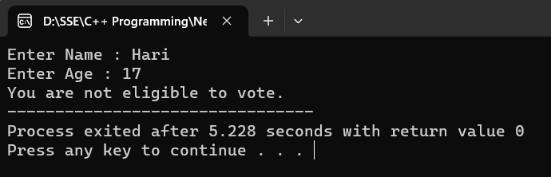

1. Multiple Catch

Program :

#include<iostream>

#include<string>

using namespace std;

int main()

{

int age;

string name;

try

{

cout << "Enter Name : ";

cin >> name;

cout << "Enter Age : ";

cin >> age;

if (age<18)

{

throw age;

}

else

{

cout << "You are elgible to vote.";

}

}

catch (const char \*e)

{

cout << "You are not eligible to vote.";

}

catch (float x)

{

cout << x << "Not eligible.";

}

catch (int y)

{

cout << "Age : " << y << " Not eligible to vote.";

}

return 0;

}

Output :

